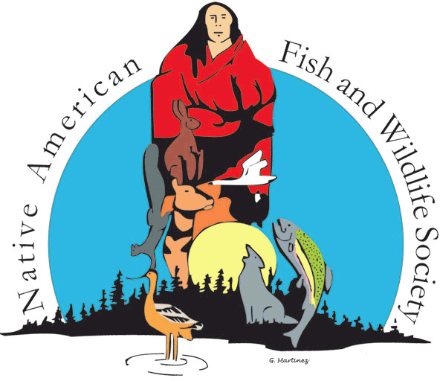
Native American Fish & Wildlife Society
Northeast and Southeast
Joint Regional Conference
September 10 - 11, 2024
Indigenous Environmental Education Center – Warsaw, VA
Host Tribe: Rappahannock Tribe
Tuesday, September 10, 2024
 | 7:00 a.m. – 5:00 p.m. | Registration & Information  Coordinators: Heidi McCann, NAFWS Office Manager/Membership Coordinator & Jennie Bills, MPartners
 | 7:00 a.m. – 5:00 p.m. | Exhibitors & Vendors  Coordinator: Heidi McCann, NAFWS Office Manager/Membership  Coordinator & Jennie Bills, MPartners
GENERAL SESSION
Moderators: Ben Simpson, NAFWS NE Board of Director
Mike LaVoie, NAFWS SE Board of Director
 | 8:00 a.m. – 8:30 a.m. | Opening Ceremony  Posting of the Colors  Maskapow Drum Group  Invocation and Welcoming Remarks:  Mark Fortune, Assistant Chief, Rappahannock Tribe  Julie Thorstenson, Executive Director, NAFWS  Ben Simpson, NE Region Board of Director, NAFWS  Mike LaVoie, SE Region Board of Director, NAFWS
 | 8:30 a.m. – 9:00 a.m. | Title: Rappahannock Tribal Overview  Speaker: Mark Fortune, Assistant Chief, Rappahannock Tribe
 | 9:00 a.m. – 10:00 a.m. | Title:  Oklahoma Tribes Sign Historic Hunting and Fishing Compact  Speaker: Jay Harvey, Game Warden, Choctaw Nation of Oklahoma
 | 10:00 a.m. – 10:15 a.m. | BREAK
 | 10:15 a.m. – 10:45 a.m. | Title:  Working Together: Tribal Nations and the Climate Adaptation Science Centers for Adaptive Wildlife and Resource Management  Speakers:  Ashley Fortune Isham, Research Coordinator, USGS – Northeast Climate Science Adaptation Center  Hailey Shanovich, PhD, ORISE Postdoctoral Fellow, USGS - Southeast Climate Adaptation Science Center
 | 10:45 a.m. – 11:15 a.m. | Title:  Incorporating Indigenous Knowledge into Conservation and Restoration: An Overview of the Southeastern Grassland Institute’s Tribal Program  Speakers:  Katie Smith-Easter, Southeastern Grasslands Institute, Austin Peay State University  Corlee Thomas-Hill, Tribal Liaison, Southeastern grasslands Institute
 | 11:15 a.m. – 11:45 a.m. | Title:  Integrating Tribal priorities into regional conservation plans – Rivercane and the Southeast Conservation Blueprint  Speaker: Louise Vaughn, Blueprint User Support Specialist, Southeast Conservation Adaptation Strategy (SECAS)/U.S. Fish and Wildlife Service
 | 11:45 a.m. – 1:15 p.m. | Business Luncheon  Coordinator: Mike LaVoie, NAFWS Board of Director, SE Region & Ben Simpson, NAFWS Board of Director, NE  Presentation: NAFWS National Updates, Dr. Julie Thorstenson, NAFWS Executive Director  Member Business/Discussion  NE and SE Regional Board of Director Election  ** Lunch Provided **
 | 1:15 p.m. – 1:45 p.m. | Title: Loss of Freshwater Biodiversity and Native Mussels: Management Actions to Promote Freshwater Ecosystem Resilience and Health  Speaker: M. Camille Hopkins, Wildlife Disease Coordinator, U.S. Geological Survey - Biological Threats and Invasive Species Research Program
 | 1:45 p.m. – 2:15 p.m. | Title: Create, Train, Self-Sustain: Research Modules Bolster Capacity to Maintain Sovereignty  Speaker: Jessica Nagel, Lead Fish and Wildlife Biologist, Eastern Band of Cherokee Indians
 | 2:15 p.m. – 2:45 p.m. | Title:  Improving Winter Tick Sampling to Monitor Impacts on Moose on Penobscot Nation Land  Speaker: Ben Simpson, Wildlife Resource Manager, Penobscot Nation
 | 2:45 p.m. – 3:00 p.m. | BREAK
 | 3:00 p.m. – 3:30 p.m. | Title: Seminole Drone Program  Speaker: Craig van der Heiden, Acting Director Environmental Science Department, Seminole Tribe
 | 3:30 p.m. – 4:00 p.m. | Title:  NAFWS Research and Publications Committee Update  Speaker: Hannah Golden, Fish and Wildlife Biologist, NAFWS
 | 4:00 p.m. – 4:30 p.m. | Title:  Trends in Tribal Invasive Species Management – NAFWS Edition  Speaker: Mitzi Reed, Invasive Species Coordinator, NAFWS
 | 4:30 p.m. – 5:00 p.m. | Title:  Insights on Youth Program Development and NAFWS Education Updates  Speaker: Ashley Mueller, Education Coordinator, NAFWS
 | 5:00 p.m. | ADJOURN
 | 6:30 p.m. – 8:30 p.m. | Dinner Provided
Wednesday, September 11, 2024
 | 8:00 a.m. – 12:00 p.m. | Field Trips  Option 1: Fall migratory bird walk through the Cat Point Creek Refuge unit  Address: 2570 Newland Rd., Warsaw  Instructions: Be weather-prepared.  Option 2: Tour of the Rappahannock Tribe’s Government Center and the Chief’s House Rehabilitation site  Address: 5036 Indian Neck Rd., St. Stephen’s Church, VA 23148  Instructions: Transportation is on your own.
 | 12:00 p.m. – 1:00 p.m. | LUNCH – ON YOUR OWN
AMERICA THE BEAUTIFUL INITIATIVE AND NATIONAL COASTAL REILIENCE FUNDING AND TRIBES
Moderators: Ben Simpson, NAFWS NE Board of Director and Mike LaVoie, NAFWS SE Board of Director
 | 1:00 p.m. – 1:30 p.m. | Title:  America the Beautiful and NAFWS Technical Assistance Overview  Speaker: Andy Edwards, America the Beautiful Challenge Field Liaison, NAFWS
 | 1:30 p.m. – 2:00 p.m. | Title:  Tribal-led Connectivity Projects in the Penobscot River  Speaker: Dan McCaw, Fisheries Program Manager, Penobscot Nation
 | 2:30 p.m. – 3:00 p.m. | Title: Advnisdisgi: Designing a Cherokee Planning Project for Conservation Across Jurisdictions  Speaker: Mike LaVoie, Natural Resources Director, Eastern Band of Cherokee Indians
 | 3:00 p.m. – 3:15 p.m. | BREAK
 | 3:15 p.m. – 3:45 p.m. | Title:  The Rappahannock Tribe’s Return to the River  Speaker: John Reid Ryan, Director of Environmental and Natural Resources, Rappahannock Tribe
 | 3:45 p.m. – 4:15 p.m. | Title:  Building Chickahominy Tribal Community Capacity to Create a Coastal Resilience Plan  Speaker: Joe Hunt, Environmental Project Manager, Chickahominy Tribe
 | 6:00 p.m. – 8:00 p.m. | Banquet  Invocation  Retire the Colors
THANK YOU TO OUR SPONSORS:
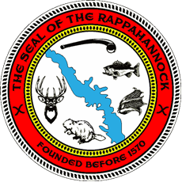 | 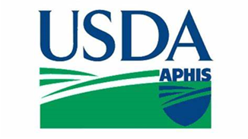
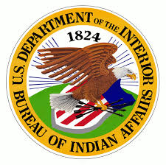 | 