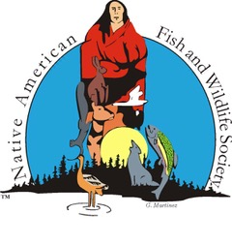
Conference Sponsorship Information:

Platinum Level Sponsor: Your contribution of $10,000 or more entitles you to the following:

Company sign in a prominent area

Free double exhibition booth.

Three (3) free full conference registrations.

Verbal recognition at the general session and speaking time at the banquet

Prominent listing and logo presence in the conference program and promotional materials

Social media recognition

Gold Level Sponsor: Your contribution of $5,000 or more entitles you to the following:
- Company sign in a prominent area.
- Free double exhibition booth.
- Two (2) free full conference registrations.
- Verbal recognition at general session and banquet.
- Prominent listing and logo presence in the conference program.
- Social media recognition

Silver Level Sponsor: Your contribution of $3,000 or more entitles you to the following:
- Company sign in a prominent area.
- Free exhibition booth.
- One (1) free full conference registration.
- Verbal recognition at general session.
- Social media recognition
- Listing in the conference program.

Bronze Level Sponsor: Your contribution of $2,000 or more entitles you to the following:
- Company sign in a prominent area.
- Verbal recognition at general session.
- Social media recognition
- Listing in the conference program.

If interested in becoming a major sponsor, please contact Heidi McCann, Office Manager/Membership Coordinator at HMcCann@nafws.org or
by telephone at 303-466-1725 ext. 2 or cellphone at 720-822-3368

Board of Directors approved 11/21/19

