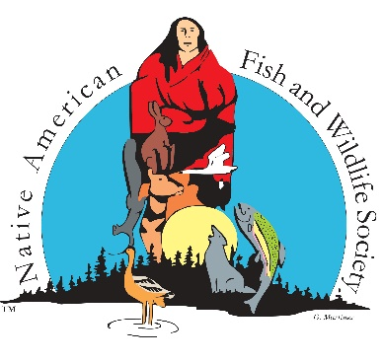
NATIVE AMERICAN FISH & WILDLIFE SOCIETY
10465 Melody Drive, Suite 307
Northglenn, CO 80234

**REQUEST FOR VENDORS**

The Native American Fish and Wildlife Society (NAFWS), established in 1983, is a non-profit 501 (c)3 organization with a mission to assist Native American and Alaska Native Tribes with conservation, protection and enhancement of their fish and wildlife resources. We serve 227 Native American and Alaska Native member Tribes. We are a national organization, based in the Denver, CO area.

NAFWS is seeking Vendors for our 38th Annual Native American Fish & Wildlife Society National Conference to be held October 4-October 7, 2021, at the Northern Quest Casino in Spokane Washington. Vendor Cost

$500 Corporate
$400 Federal/State Agencies
$200 Tribal/Inter-Tribal/Non-Governmental Organizations
$75 Native American Vendor (Native crafts, jewelry, art) (Price for Native American Vendors will be $50 with donation of item of equal value)

Please contact Corey Lucero, clucero@nafws.org, 505/435-1644 to register.

