!!!!!!ALERT!!!!!!
HIGHLY PATHOGENIC AVIAN INFLUENZA (HPAI)

This ALERT is to inform the reader that the Highly Pathogenic Avian Influenza (HPAI) virus, (H5N1) has been reported in (Insert State/County/Reservation).

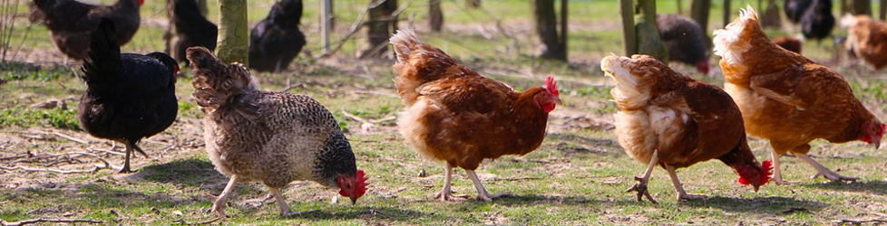
SLC.gov
HPAI, or Bird Flu, is a highly contagious virus among birds, especially poultry. If you have backyard flocks of chickens, turkeys, pheasants, peacocks, guineas or other exotics, please protect them now from coming into contact with any wild birds.
Practice good biosecurity measures such as:
- Not allowing entry of wild birds into your coop or around your flocks.
- Do not allow other people to feed your animals.
- Wash hands thoroughly before feeding your flock.
- Do not track through wild bird poop then enter your coop.
- Avoid allowing any food to remain on the ground that may attract wild birds or rodents.
- Wild bird rehabilitators should use all PPE precautions.
THERE HASN’T BEEN ANY REPORTED HPAI CASES IN HUMANS BY THIS STRAIN OF THE HPAI VIRUS.
If you encounter any dead birds, wild or domesticated, DO NOT TOUCH THEM, please report it immediately to your Tribal Conservation Law Enforcement Officers, Law Enforcement Officers, Tribal Administration etc.

Corey Lucero, Fish & Wildlife Biologist, clucero@nafws.org, 505/435-1644

