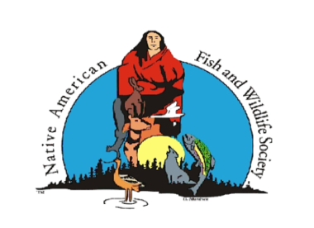
NAFWS Southwest Region - Business Meeting & Luncheon
Santa Ana Star Casino Hotel
Tuesday, August 23, 2022
11:30 am – 1:30 pm
Agenda
- Opening Prayer
- Call Meeting to Order – Darren Talayumptewa, SW Region Director
- Opening Remarks/Welcome – Darren Talayumptewa & Selso Villegas (Alternate) – SW Region Directors
- Julie Thorstenson, Executive Director - Update on the Society
- Updates:
- 2023 Annual Natural Resources Youth Practicum – (Darren/Norman)
- Input on potential 2023 Trainings for SW Region – Planning & Budgeting
- Scholarships – Update (Darren)
- 2022 New Board Officers for the Society – Elveda Martinez (SW), President, Mike LaVoie (SE), Vice-President & Mitzi Reed (SE), Secretary/Treasurer
- Tribal Resilience Funding for Adaptation Planning; $15,000.00 – for this year’s Climate Change sessions at the National & Regional Conferences; requests will be done on a reimbursement basis. Requested additional travel funds for 2023.
- Update on SW Region Water for Wildlife Project – Kaleidoscope Consulting.
- Public Information Officer Quarterly Report/Social Media Update (Darren)
- 2023 National Conference – Anchorage, Alaska
- Resolutions:
- Resolutions from the floor.
- SW Director Election/Darren Talayumptewa’s term is up. Nominations & Election
- Questions/Concerns from the membership.
- Motion to Adjourn.

