developing an invasive species management plan workshop
Agenda

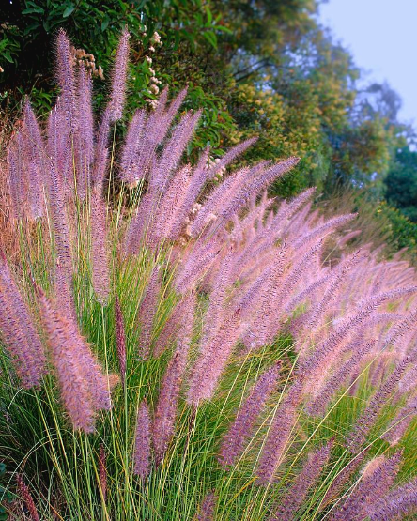
Workshop Location: | Itom Hiapsi Tribal Building  9405 S. Avenida del Yaqui  Guadalupe, AZ 85283
Date: | April 9, 2024
Time: | 9:00am – 5:00pm
Hosted By:  Additional Information: | Native American Fish and Wildlife Society  Pasqua Yaqui Tribe  AGENDA:  Morning: Presentations by Tribes with Invasive Species Management Plans  Lunch: Provided by NAFWS to Participants/Speakers  Afternoon: NAFWS – elements to include in an Invasive Species Management Plan
Lodging: Holiday Inn Express Tempe
1520 West Baseline Road
Tempe, AZ 85283

Transportation: Participants Responsibility
Yellow Cab: 480-888-8888
Bus 48 56 77

Register: NAFWS.org

