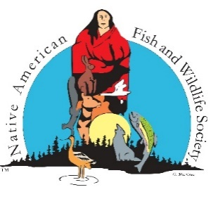NATIVE AMERICAN FISH & WILDLIFE SOCIETY

10465 Melody Drive, Ste. 307, Northglenn, CO 80234

303-466-1725

[www.nafws.org](http://www.nafws.org)

**NAFWS SW Regional Conference**

**Tachi Palace Casino & Resort**

**Climate Change Workshop**

**Monday, August 12, 2024 - 9:00 am – 12:00 noon**

**Agenda**

9:00 am Opening/Introductions – Ashley Mueller, Education Coordinator

- NAFWS National Office

-Travel Assistance Information; send to [amueller@nafws.org](mailto:amueller@nafws.org) w/receipts

9:15 am “**Cimate Adapted Silviculture – Regarding Reforestation and Stand Density Management”**

Marianne Emmendorfer, MS

Forest Silviculturist/Giant Sequoia Specialist and Pesticide Use Coordinator

Sequoia National Forest, Giant Sequoia National Monument

10:00 am Break

10:15 am “**California Native American Perspectives on Climate Change During the Past 20 Years. Public entity inclusion of Tribal Ecological Knowledge regarding climate change. Indigenous peoples impact to climate change related policy. Open discussion.”**

Dr Donna Miranda-Begay

Tubatulabal Cultural Practitioner and Researcher

Tubatulabal, Tule River Yokut, Paiute, and Dine'

CA Tribal GIS, CEO - http://www.catribalgis.org/

CA GIA, Board Member - www.cgia.org

11:15 am **"Navigating Climate Change on the Navajo Nation"**

Keith Howard, Programs and Projects Specialist

Navajo Nation Department of Fish & Wildlife

Climate Change Program

12:00 Noon Adjourn - Lunch