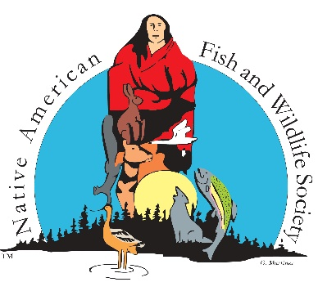
NATIVE AMERICAN FISH & WILDLIFE SOCIETY
10465 Melody Dr., Ste. 325, Northglenn, CO 80234
(303)466-1725
www.nafws.org

OPEN TO ALL NAFWS NATIONAL CONFERENCE ATTENDEES
Federal & State Relations Committee Agenda
5/12/25 10:00 am – 12:00 pm
Wind River Hotel & Casino – Riverton, WY
Blue Sky 2

BACKGROUND:

PURPOSE: Establish a Board of Directors committee to facilitate partnerships and communication with Federal and State partners.

DUTIES:
- Provide opportunity for discussion, deliberation, and action with respect to fish and wildlife conservation in the context of the three sovereign entities which have various jurisdictional authority over these resources: Tribal governments, the Federal Government and state fish and wildlife agencies.
- Coordinate effective delivery of stewardship and conservation of fish and wildlife resources.
- Seek the highest standards for conservation activities to ensure that actions and resources are effective and efficient.
- Assure the appropriate jurisdictional relationship between the three sovereign entities in legislative, executive and treaty initiatives.

MEMBERSHIP: The FSR will be composed of five (5) voting members and three (3) ex-officio members as follows:
- three (3) Board of Directors selected by the Regional Directors
  - Michael LaVoie, Orville Huntington, Benjamin Simpson
- two (2) NAFWS members at large; Marc Ohm & Doug Craven
- one (1) ex-officio member representing the State Fish and Wildlife Agencies (e.g. AFWA) - PENDING
- two (2) ex-officio member representing the Federal Fish and Wildlife/Conservation Agencies
  - Thomas Mendez, BIA
  - Karen Cogswell, FWS

MEETINGS: The FSR Committee will meet at least quarterly with one meeting in person at the Annual NAFWS National Conference.

- Call to Order – Julie Thorstenson, PhD
- Welcome and Introductions
- Federal Updates (3-5 minutes each)
  - BIA
  - FWS
  - USGS
  - BLM
  - USFS
  - Other
- State Updates (3-5 minutes each)
  - AFWA
  - Individual States present
- General Discussion
- Other
- Adjournment

