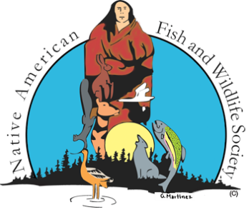

**Native American Fish and Wildlife Society**

**NAFWS National Conference**

**Invasive Species Management Workshop**

**Riverton, Wyoming**

**May 12, 2025**

**No other animal has had an iconic following more than the wild/feral horse, even being accepted as an integral part of many tribal cultures; however, the realization of the matter is that free roaming horses are in fact invasive species causing significant damage to tribal landscapes and disrupting the natural balance of the ecosystem in which they inhabit. Populations of wild and/or feral horses are wreaking havoc over tribal lands by compounding watershed functions, altering wildlife presence and behavior, outcompeting native wildlife for food and water resources, damaging native plant communities, and creating loss of culturally significant species that Tribes depend on for food, medicine, and ceremony. The trampling of vegetation, overgrazing, and compacting soils change the landscape resulting in the growth of fewer desired and/or native plant species, less plant cover, and the spread of more invasive plants, which in turn, results in less abundant habitat for other smaller native populations. The encroachment of feral horses onto tribal lands has left Tribes in the position to make difficult and realistic decisions to protect their respective tribal lands to resolve a real problem.**

***\*\*Limited to 30 participants. Meet outside the hotel lobby at 11:30 am on Monday, May 12, 2025. Ride to Wind River Reservation starting at 11:45 am. Approximately a 30–45-minute drive.***

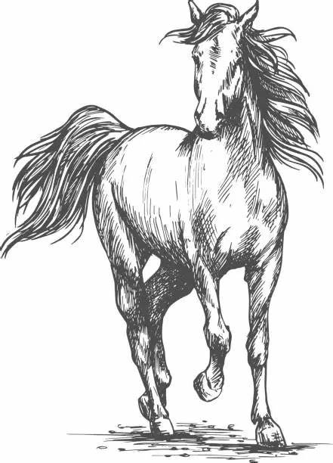**12:30 pm** Arrival to Wind River Reservation – Fort Washakie with site visit to see changes to landscape following feral horse removals

* Art Lawson

**1:45 pm** Travel to offices of Shoshone & Arapaho Fish and Game for feral horse program efforts presentation

* Art Lawson and Wilma Wagon

**2:30 pm** Cheatgrass concerns following removal of feral horses

* Pat Hnilicka, Art Lawson, Wilma Wagon, Mitzi Reed

**3:00 pm** Feral Horse Zoonotic Disease Concerns

* Dr. Tolani Francisco

**3:30 pm** Recognizing Public Perceptions and Addressing the Negative

* Art Lawson

**4:00 pm** Tribal Roundtable: The Good, The Bad & The Ugly?

Opportunity to have an open discussion on the aspects of a Feral Horse Program that will include dialogue on beginning a program to processes of sustaining that program. Real talk on real issues.

**4:30 pm** Return back to Wind River Hotel & Casino in time for Great Plains Members to attend Great Plains Business Meeting at 5:30 pm.