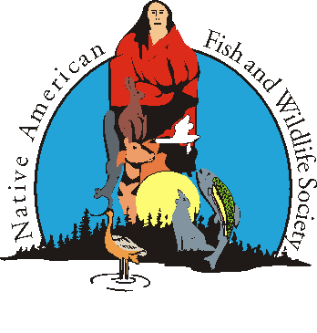

NAFWS Research & Publication Committee National Conference Meeting Agenda
*This is a closed meeting; only current members of the committee may attend*
Monday, May 12, 2025, 9:00-10:00 a.m.
Location: Blue Sky 1
Coordinator: Hannah Golden, Fish & Wildlife Biologist - NAFWS
9:00 a.m. | Welcome
9:05 a.m. | Updates and Announcements  From the Field Review  - From the Field Status Review  - Initial Review  - Sorting of content  - General Issue Design  - Next Steps
9:55 a.m. | Next Meeting  June 10th, 2025, 2:00-3:00 p.m. CST
10:00 a.m. | Adjourn

***We are searching for individuals who are interested in getting involved in this committee. You do have to be a NAFWS Individual Member to be involved. ***
From the Field Forms:
Peer Review Volunteer Form
https://app.smartsheet.com/b/form/516850a8c2934f6884bdd9eae134902a
Submission Form:
https://app.smartsheet.com/b/form/7bec3d3a741745d4b18b553b84066d03

