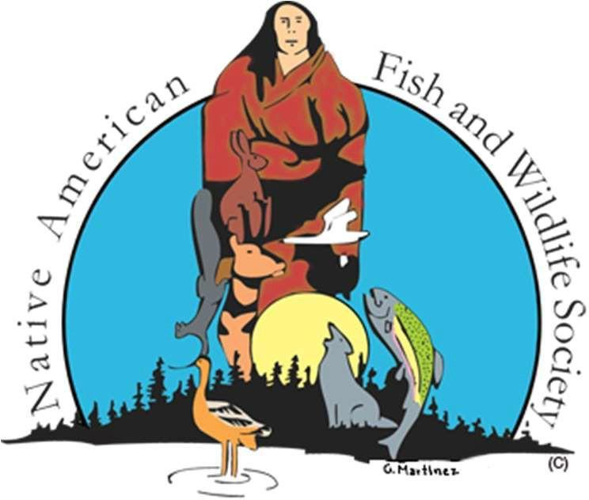 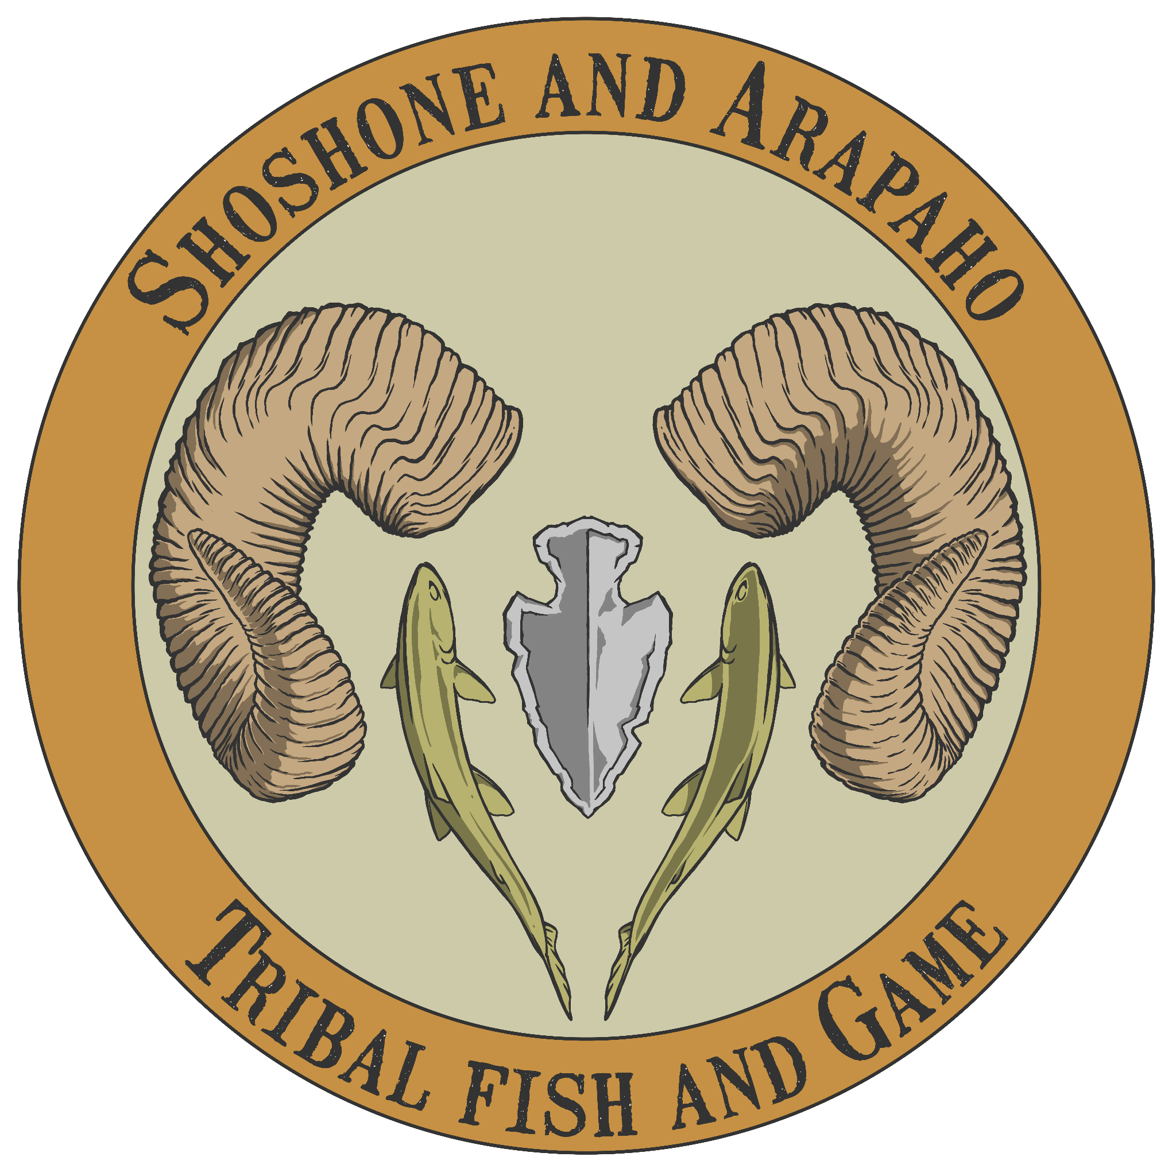

Native American Fish & Wildlife Society

Wildlife Health & Chronic Wasting Disease Workshop

2025 NAFWS Annual National Conference

Co-hosted by the Eastern Shoshone & Northern Arapaho Tribes of the Wind River Reservation

May 12th, 2025 Wind River Hotel & Casino

Riverton, Wyoming

*Coordinator: Shailyn Wiechman, NAFWS Wildlife Connectivity Coordinator,* [*smiller@nafws.org*](mailto:smiller@nafws.org)

*\*Please wear closed-toe shoes, pants, and clothing you don’t mind getting dirty\**

**Monday, May 12th, 2025**

# Classroom - Spring Mountain Room

9:00 am **Welcome & Introductions**

*Shailyn Wiechman, Wildlife Connectivity Coordinator, NAFWS* Tolani Francisco, Wildlife Disease Consultant - Native Healing, LLC Tim Linder, Wildlife Disease Biologist, USDA APHIS

*Scott J. Chiavacci, Ecologist, USGS*

9:15 am – 9:45 am **Wildlife Diseases** *Rabies SARs-CoV-2*

*Highly Pathogenic Avian Influenza (HPAI)* Vector-Borne Diseases

*Swine Flu*

*White-nose Syndrome Bovine Tuberculosis*

9:45 am – 11:45 am **Chronic Wasting Disease (CWD)**

*Presentations:*

## *State of Science: Chronic Wasting Disease*

* *Scott J. Chiavacci, Ecologist, USGS*

## *Wind River Reservation CWD Management*

* *Tucker Russell, Graduate Research Assistant, University of Wyoming*

## *Navajo Nation CWD Management*

* *Jessica Fort, Wildlife Biologist, Navajo Nation Fish and Wildlife Department*

11:45 am **Debrief & Hands-on training instructions**

12:00 pm - 1:30 pm **Lunch on your own**

# Hands-on Training - Front lawn of the Casino

1:30 pm – 2:00 pm **Personal Protective Equipment (PPE)** *Demonstration & Application of: Gloves*

*Footwear* Protective clothing

*Face shields and masks*

2:00 pm - 4:30 pm **Disease Sampling on lamb heads and birds**

*Chronic Wasting Disease* SARs-CoV-2

*Highly Pathogenic Avian Influenza (HPAI)*

4:30 pm – 4:50 pm **PPE removal and Cleanup**

4:50 pm – 5:00 pm **Debrief & Conclusions**