Pronghorn Connectivity and Demography across the Northern Sagebrush Steppe: An assessment of potential ‘Lost Migration’

Between 2003 and 2010, 185 pronghorn were captured and monitored in the Northern Sagebrush Steppe of Alberta, Saskatchewan, and Montana (Figure 1). From this research we gained an in-depth understanding of the habitat selection^{1,2}, movement and migration patterns^{3,4,5} and the risk and survival^{6,7} of pronghorn in this highly altered landscape. Associated with this work was an understanding of the role roads and fences play on the selection and movement of pronghorn^{8,9}. We were also able to document the longest spring migration and annual movement distance traveled for the species across its range^{4,5}. Yet, this initial effort had collars deployed on individuals for only 50-52 weeks over a seven-year period and therefore limited any assessment of use of long-term migratory route use, movement tactic plasticity in individuals, barriers to functional connectivity, and how migration influences population demographics.
The initial project determined that greater than half of collared pronghorn were migratory (55% migratory vs 45% resident) with animals moving north-south on a yearly basis, between provinces, and internationally across the Canada-USA border⁴. During extreme winter snowstorms, pronghorn made directional and very linear movements (termed ‘facultative winter movements’), travelling south to avoid severe conditions⁴. These annual migrations, as well as the directional movements, resulted in higher survival rates for migratory animals compared to residents^{6,7}. Therefore, to maintain healthy viable populations of pronghorn at the edge of the species range, ensuring connectivity across the Northern Sagebrush Steppe (NSS) is essential for their long-term conservation.

Since our initial work almost two decades ago, the landscape has seen dramatic change across this region. This is most evident along transportation corridors, particularly in the vicinity of Highways 1 and 3 in Alberta and US Highway 2 in Montana, at migration key linkage areas where pronghorn attempt to cross north and south during their spring and fall movements. In Alberta, urban and industrial expansion around Medicine Hat and Dunmore limits the ability of pronghorn to freely move north and south as they approach these busy key linkage areas. There are plans to twin Highway 3 east of Taber, potentially making highway crossings far more unlikely in the future. In addition, there are energy developments planned and being built within the very long north-south migration corridor within Alberta. These structures vary, although one facility will have an eight-foot page wire barrier covering 18 km² (7 sections).

Potential movement barriers north of the South Saskatchewan River are also on the rise with planned and developing industry structures that may result in direct and indirect habitat loss. In other jurisdictions, pronghorn have shown sensitivity to structures and the activity associated with some forms of new energy (e.g., wind and solar power) with both direct and indirect habitat loss, changes in pronghorn movement rates, as well as shifts in migration pathways^{10,11}. In Montana, a Western-wide Environmental Impact Statement (EIS) has identified the Milk River Breaks as a key area for potential solar farm development.

We predict this accumulation of anthropogenic and linear features will create a high disturbance zone that will impede normal pronghorn migration, as well impede directional movements south to avoid severe snowstorms over the entire winter period. The inability to freely move across the landscape may result in changes to survival rates especially during severe winters.

The legacy of these anthropogenic landscape features may have had historical and/or ongoing impacts on the functional connectivity of pronghorn populations, reshaping important meta-population dynamics and altering demographic processes related to gene flow and the geographic distribution of important genetic diversity. While anthropogenic and geographic features did not appear to impact gene flow in the core of pronghorn range¹³, we hypothesize that the extremes of the periphery of their range in the NSS may result in distinctive genetic signatures that have manifested in response to landscape features, both natural and anthropogenic. We predict that these signatures will provide important context for understanding pronghorn migration behavior and the role of population connectivity in pronghorn persistence.
Migrations and long-distance movements are being 'lost' globally, from incremental land changes¹⁴ - cultivation, renewable and nonrenewable resources (e.g., solar, oil/gas development), linear features (e.g., roads, fences), etc. Stemming from this concern, the Global Initiative for Ungulate Migrations (GIUM) was launched to conserve migrations, globally, as they are a key process that maintains ecological functionality and resiliency.

Significantly, we are working with tribal nations on extending this project South from Alberta and Saskatchewan, into Northern Montana, to reassess pronghorn connectivity and impacts from barriers across the NSS (Figure 1). Our research team would like to work with tribal nations for several reasons: 1) We have much knowledge and lessons to gain from working with tribal nations 2) We could help provide capacity with increased funds to tribal nations 3) the four Hi-line Tribal Reservations are spatially well-situated across Northern Montana to sample pronghorn and gauge overall connectivity.

Significance

The primary aim of our work will be to reassess connectivity for pronghorn and characterize their genetic diversity given the current and proposed changes to occur on across the NSS. The potential barriers influencing their migrations in the northern extent of the species’ range are increasing in severity and complexity every year. We know that movement and gene flow are impacted by many factors, and if landscape change continues without check or mitigation, then pronghorn migration, and ultimately their distribution, will continue to be diminished. Pronghorn distributions and movements will be assessed in relation to transportation corridors, specifically Highway 1 in Alberta and Saskatchewan and US Highway 2 in Montana. Over time these barriers may reach critical thresholds that prohibit pronghorn from escaping harsh winter conditions or moving to important fawning ranges, either of which is predicted to decrease the total carrying capacity and effective population size across the NSS. Our research will reveal how pronghorn movement and associated survival and genetic structure is influenced by anthropogenic barriers, and whether these barriers have shaped and impacted meta-population dynamics related to genetic diversity, population demographics, and gene flow. Understanding these foundations of pronghorn ecology will enable us to better estimate what thresholds of linear and anthropogenic disturbances are impactful to the species, project when thresholds are reached, and inform the conservation and management mitigation process to take the necessary measures available to allow pronghorn to maintain populations at the northern periphery of their range. Overall, the team looks to evaluate if migrations are being 'lost' 20 years after our initial project (from 2003–2011), as there has been formidable development over these past 2 decades.

As significant, working to include and integrate Traditional Ecological Knowledge (TEK) by learning from Native American tribal personnel will help to better link historical context and cultural significance into model outputs, management objectives and mitigation opportunities. As far as we know, this research project is one of the first of its kind, globally, to assess 'lost migrations', which was identified as critical for our understanding at the recent GIUM conference in July 2023. In addition, it is the first study in the United States that will assess and integrate TEK and migration/movement data into model outputs for wildlife management and ecological connectivity. We have met with the four Tribal Fish and Wildlife Departments and have confirmed interest in bringing on a M.S. student at the University of Montana from one of the tribes to collect indigenous knowledge on collectively understood pronghorn migratory routes and include this in our understanding of 'lost migrations'. There are opportunities to ask additional questions that are significant to each individual tribal management objectives as well as integrate Traditional Ecological Knowledge (TEK) into our understanding of wildlife movements and migrations. We all realize that with GPS collars, we are only collecting data from the last 20–25 years. We'd like to include and support TEK that goes back multiple generations.

Accumulated Research Questions from Partners
- Have migration pathways and connectivity changed from those described in the original study with movements made between 2003–2011 across the NSS? The NSS landscape has significantly changed since our original study and pronghorn may no longer follow similar migration pathways as originally documented.

- Are migratory pronghorn in the spring able to follow spring green-up (surf the green wave) as they move north? A study in Wyoming indicated that as oil and gas developed to a certain threshold that mule deer became de-coupled from the green wave and no longer benefited from migrating¹². Similar to the green-wave, in the fall are pronghorn able to stay ahead of the accumulating snow (surf the white-wave) to allow them to migrate to more conducive environments to facilitate over winter survival? We have already seen mass-die offs during severe winters across the NSS due to pronghorn being impeded by fences, roads, and railroads when trying to move south during severe winters. Are these phenomena increasing due to a changing landscape in the NSS?

- How are the migration patterns of pronghorn (pathways and use of stopover sites along the route) impacted by infrastructure and linear features (roads, fences, etc.)? Initial work in Wyoming indicates that ungulates adjust their movement patterns (e.g., speed up when in proximity to infrastructure) as a response to these footprints^{10,11,12}.

- Do collared pronghorn show plasticity in movement tactics from year to year? That is, if a female pronghorn is migratory during the first year she is collared, does she exhibit this same migratory behaviour every subsequent year?

- If we see changes in migration patterns, do these changes result in changes to annual and winter survival rates for pronghorn in the NSS?

- What can the Tribes teach us (TEK) about historic pronghorn movement and migrations in their areas? How can this information then be used to assess landscape change impact to movement and migrations over longer temporal periods and spatially within and between each reservation?

- How can this study be helpful in guiding management objectives for each Tribal Reservation and identify funding opportunities to increase tribal capacity and mitigation prospects within each reservation?

- Are pronghorn able to migrate from areas north of Highway 1 to wintering areas south of the highway in Saskatchewan? While predicted connectivity was mapped in Saskatchewan during the original study, no animals were captured and collared north of the highway and animals that were collared south of the highway did not venture north of Highway 1. Therefore, collaring animals north of the highway will help determine if these predicted migration corridors are functional.

- Does connectivity influence population density and declines during severe winters in Alberta, Saskatchewan, and/or Montana? We will compare population demographic rates (buck:doe, fawn:doe, and survival) in Alberta and Saskatchewan related to an individual’s ability to move / migrate north and south of Highway 1, as well as in Montana related to an individual’s ability to move/migrate north and south of US Highway 2. This study question may provide insights into what may happen to the NSS pronghorn populations if connectivity is lost, especially if we document that pronghorn in Saskatchewan are not able to move south across Highway 1.

- While spatial connectivity and migration routes use can be validated with collared individuals, gene flow is the ultimate important indicator of functional connectivity. Indeed, the patterns and fluctuations of gene flow calculated from genetic data are robust methods for measuring connectivity across demographic and geographic scales. We will use population and landscape genetic methods to describe pronghorn population and meta-population dynamics, and determine whether the impacts that anthropogenic and natural landscape features have on migratory behaviors have also impacted patterns of genetic diversity.

Methodology
Pronghorn Capture and Collaring
106 female pronghorn were captured in Alberta and Saskatchewan in December 2024, which was be performed by Bighorn Helicopters Inc., following all animal care protocols. All processing occurred at the site the pronghorn was captured at, with animals released in a timely fashion to reduce chances of capture myopathy¹⁵.

In Alberta and Saskatchewan, collar sampling was divided into two distinct study areas, one north and one south of Highway 1 (Figure 1) and monitored for four years. Captures north of Highway 1 will also include animals on CFB Suffield, permit pending. Captures will occur during the first three years (2024, 2025, and 2026). Additional animals will be captured to replace collars from animals that die and/or go missing on an as-needed basis (yearly during winter). In Montana, capture permits will be obtained from each of the four Hi-Line tribes (Figure 1). A minimum of 20 collars (30 collars max) will be deployed on female pronghorn each year, per each tribal reservation. Captures will occur in equal distribution, and where possible, North and South of US Highway 2 to assess the potential impacts of transportation corridors on pronghorn distribution, movements, and connectivity. We anticipate the study will take 5-7 years to complete including data acquisition, analysis, and publication of results.

During captures, we will affix a satellite GPS collar (either a Lotek LiteTrack Iridium 420⁺ collar, LiteTrack Iridium S⁺ with camera, or PinnaclePro⁺ M S with solar panel) to each pronghorn. All collars have a remote trigger drop-off so that collars can be removed from all animals at the end of the study. Collars will remain active and acquire locations over an approximate 3-4-year period in Canada (Table 1) and Montana (Table 2). Collars are scheduled to obtain a location every 5 hours, unless the animal moves within 4 km on either side of Highway 1 and Highway 3 in Alberta/Saskatchewan or US Highway 2 in Montana, at which point the collar will collect a location every 15 minutes. Once the pronghorn leaves the 4 km buffer, the schedule will return to every 5 hours.

Table 1: Pronghorn capture schedule and monitoring period for Alberta and Saskatchewan
Pronghorn |  | Y1 | Y2 |  | Y3 |  | Y4 | Y5 |  | Y6
Capture Event |  | 2024 | 2025 |  | 2026 |  | 2027 | 2028 |  | 2029
 |  | 104 Females
 |  |  | 104 Females
 |  |  |  |  | 104 Females
 | Period animals captured
 | Period collars monitored

Table 2: Pronghorn capture schedule and monitoring period across the four Hi-Line Tribal Reservations (Blackfeet, Rocky Boy’s, Ft. Belknap, Ft. Peck)

Pronghorn |  | Y1 | Y2 |  | Y3 |  | Y4 | Y5 |  | Y6
Capture Event |  | 2025 | 2026 |  | 2027 |  | 2028 | 2029 |  | 2030
 |  | 70-110 Females
 |  |  | 70-110 Females
 |  |  |  |  | 70-110 Females
 | Period animals captured
 | Period collars monitored

Research Team:
Principle Investigators:
-Paul Jones, Senior Biologist, Alberta Conservation Association
-Amanda MacDonald, Intermediate Biologist, Alberta Conservation Association and MSc. student at University of Calgary
-Dr. Andrew Jakes, Senior Research Scientist, Wyoming Migration Initiative and Wyoming Cooperative Fish and Wildlife Research Unit, University of Wyoming

Project Advisors:
-Dr. Doug Manzer, Senior Scientist and Wildlife Program Manager, Alberta Conservation Association.
-Dr. Allyson Menzies, Assistant Professor, Faculty of Science, Department of Biological Sciences, University of Calgary (supervisor for Amanda MacDonald)
-Gerald “Buzz” Cobell, Director of Blackfeet Fish and Wildlife Department, Blackfeet Reservation
-Bobbi Jo Favel, Director of Natural Resources Department, Rocky Boy’s Reservation
-Gary Lamere, Acting Director of Fish and Wildlife Department, Ft. Belknap Reservation
-Les Bighorn, Wildlife Biologist Ft. Peck Fish and Game Department, Ft. Peck Reservation
-Dr. Mark Hebblewhite, Ungulate Ecology Professor, University of Montana
-Dr. Matthew Kauffman, Co-founder of Wyoming Migration Initiative and USGS Unit Leader of Wyoming Cooperative Fish and Wildlife Research Unit, University of Wyoming

Additional Student(s):
TBD, M.S. University of Montana
TBD, graduate student(s), University of Calgary

Current Funding
The Canadian portion of the GPS collaring component is fully funded, and first year captures occurred in December 2024. To reassess the entire NSS and fully understand the extent of potential ‘lost migrations’, funding is needed to expand the project and partnership from Canada to include Tribal Reservations along the Hi-Line in Montana and the University of Montana personnel. We anticipate that captures will begin across the Hi-Line reservations in December 2025. Funding requirements include:
- Collars for deployment on Tribal lands in Montana
- Capture of individual pronghorn from helicopter
- Capacity requirements for tribes (equipment, vehicle use/fuel, salary for technicians)
- Tuition and living expenses for Tribal M.S. student at UM
- Percentage of salary for MT investigators/advisors

Citations
1 Jones, P. F., M. Grue, M. Suitor, D. J. Bender, C, Gates, D. Eslinger, and J. Landry-DeBoer. 2015. Variability in the selection patterns of pronghorn: are they really native prairie obligates? The Prairie Naturalist 47:94–109.
2 Jones, P. F., A. F. Jakes, A. C. Telander, H. Sawyer, B. H. Martin, and M. Hebblewhite. 2019. Fences reduce habitat for a partially migratory ungulate in the Northern Sagebrush Steppe. Ecosphere 10:e02782.
3 Jones, P F., J. A. Hurly, C. Jensen, K. Zimmer, and A. Jakes. 2017. Diel and monthly movement rates by migratory and resident female pronghorn. The Prairie Naturalist 46:3-12.
4 Jakes, A. F., C. C. Gates, N. J. DeCesare, P. F. Jones, J. F. Goldberg, K. Kunkel, and M. Hebblewhite. 2018. Classifying the migration behaviors of pronghorn on their northern range. Journal of Wildlife Management 82:1229–1242.
5 Jakes, A. F., N. J. DeCesare, P. F Jones, C. C. Gates, S. J. Story, S. K. Olimb, K. E. Kunkel, and M. Hebblewhite. 2020. Multi-scale habitat assessment of pronghorn migration routes. PLoS ONE 15:e0241042.
6 Jones, P. F., A. F. Jakes, D. R. Eacker, and M. Hebblewhite. 2020. Annual pronghorn survival of a partially migratory population. Journal of Wildlife Management 84:1114-1126.
7 Eacker, D. R., A. F. Jakes, and P. F. Jones. 2023. Linear features affect the annual survival of an interjurisdictional migratory ungulate. Ecosphere 14: e4341. doi:10.1002/ecs2.4341
8 Jones, P. F. 2014. Scarred for life; the other side of the fence debate. Human–Wildlife Interactions 8:150–154.
9 Jones, P. F., S. E. Vegter, M. S. Verhage, and A. F. Jakes. 2022. Is it the road or the fence? influence of linear anthropogenic features on the movement and distribution of a partially migratory ungulate. Movement Ecology 10:37.
10 Milligan, M. C., A. N. Johnston, J. L. Beck, K. L. Taylor, E. Hall, L. Knox, T. Cufaude, C. Wallace, G. Chong, and M. J. Kauffman. 2023. Wind‐energy development alters pronghorn migration at multiple scales. Ecology and Evolution, 13(1), p.e9687.
11 Sawyer, H., N. M. Korfanta, M. J. Kauffman, B. S. Robb, A. C. Telander, T. Mattson. 2022. Trade‐offs between utility‐scale solar development and ungulates on western rangelands. Frontiers in Ecology and the Environment 20(6):345-51.
12 Aikens, E. O., T. B. Wyckoff, H. Sawyer, and M. J. Kauffman. 2022. Industrial energy development decouples ungulate migration from the green wave. Nature Ecology & Evolution, 6(11), pp.1733-1741.
13 LaCava, M. E. F., R. B. Gagne, S. M. L. Stowell, K. D. Gustafson, C. A. Buerkle, L. Knox, and H. B. Ernest. 2020. Pronghorn population genomics show connectivity in the core of their range. Journal of Mammalogy, 101(4), pp.1061-1071.
14 Tucker, M. A., Böhning-Gaese, K., Fagan, W. F., Fryxell, J. M., Van Moorter, B., Alberts, S. C., ... & Mueller, T. (2018). Moving in the Anthropocene: Global reductions in terrestrial mammalian movements. Science, 359(6374), 466-469.
15 Yoakum, J. D., P. F. Jones, J. Cancino, R. J. Guenzel, R. Seidler, A. Munguia-Vega, I. Cassaigne, and M. Culver. 2014. Pronghorn management guides. Fifth edition. Western Association of Fish and Wildlife Agencies’ Pronghorn Workshop and New Mexico Department of Game and Fish, Santa Ana Pueblo, USA.

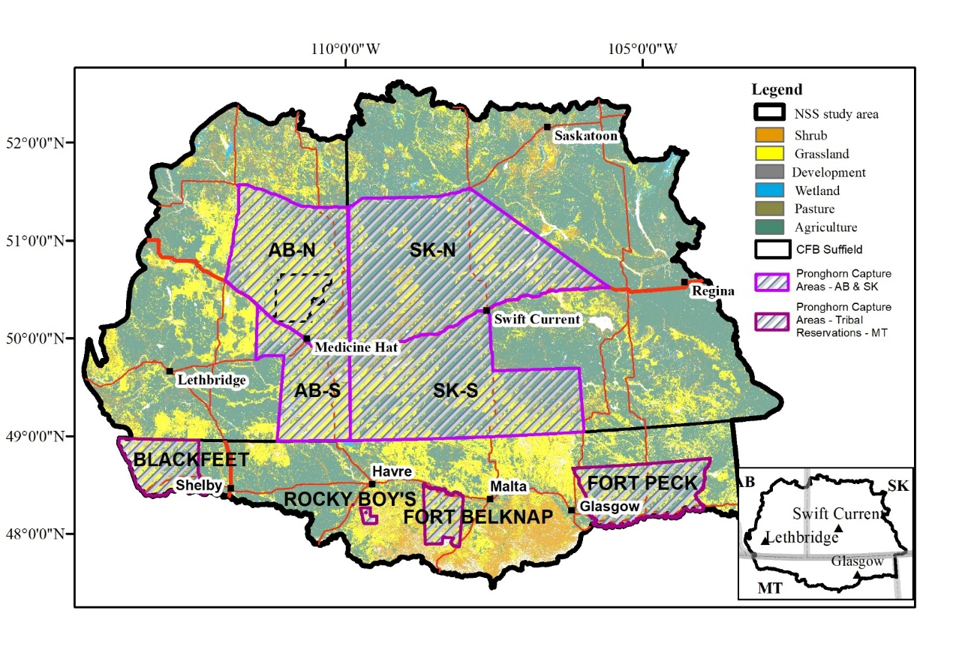
Figure 1: Pronghorn capture areas in Alberta and Saskatchewan starting in 2024. The Montana capture sites will be within the boundaries of the four Hi-Line Tribal Reservations, which include from West to East: Blackfeet, Rocky Boy’s, Ft. Belknap, Ft. Peck Reservations and will begin in December 2025.

